

**Terra Industrial New Zealand Ltd**

PO Box 16 168

16 Branston Street, Hornby

Christchurch 8441, New Zealand

03 983 2333 tel

03 983 5715 fax

www.TerraCat.co.nz



**CUSTOMER DATA STANDARDS**

Equipment

Contacts

**Terra Industrial New Zealand Ltd**

PO Box 16 168

16 Branston Street, Hornby

Christchurch 8441, New Zealand

03 983 2333 tel

03 983 5715 fax

www.TerraCat.co.nz

29 JUNE 2020

# Customer Data Standards

TC-CDS-Equipment-1.1

## Equipment

Data owners:

David Hotham, Greg McCarthy, Chris Heaton

Review:

Rental, Power Systems, Sales, Parts & Service reps, OLGA Coordinator

e.g. CSAMs, ISRs, TAMs

Update:

CSC, ISRs, Equipment, Connective Services

Not for: Credit controllers

Contents

Customer Data Standards 2

Equipment 2

Document History 4

Document information 4

Document amendment history 4

Business Rules: Equipment 5

Navigation 8

General 10

General > Machine information, Inventory 12

General > Dates 14

Technical information 16

Technical information > Engine 18

Usage information 20

Trade Information 22

Financial Dimensions 24

## Document History

### Document information

|  |  |
| --- | --- |
| Current Version | 1.1 |
| Release Date | 19 June 2020 |
| Document Owner | Jessica Macfarlane |

### Document amendment history

|  |  |  |  |
| --- | --- | --- | --- |
| Version | First Release | Sections(a) Amended | Summary of Amendment |
|  |  |  |  |
|  |  |  |  |
|  |  |  |  |
|  |  |  |  |
|  |  |  |  |

|  |  |  |  |
| --- | --- | --- | --- |
|  |  |  |  |
|  |  |  |  |
|  |  |  |  |
|  |  |  |  |
|  |  |  |  |
|  |  |  |  |

## Business Rules: Equipment

|  |  |
| --- | --- |
| Rule 1 | The Business ERP (NAXT) must be the "One Source of Truth" for Customer Equipment across the Business |
| Rule 2 | Any Business application containing Customer Equipment must be consistent with NAXT, primarily CRM (SalesLink) |
| Rule 3 | Accurate Equipment Population is imperative; all Equipment add, delete, ownership change, or update requests must be submitted through SalesLink; Equipment additions from Service will follow the NAXT Equipment workflow process |
| Rule 4 | Equipment records in NAXT must only be updated by:   * Sales Administrators / Coordinators - New, Used and Rental Machine sales * Nominated Marketing Gatekeepers - All other additions, deletions, and updates to Customer Owned fleet (Population) |
| Rule 5 | All users requesting for Equipment additions must first check in SalesLink if the Equipment already exists; This also applies to users authorised to create records in NAXT - system must flag duplicate records before creation |
| Rule 6 | All required inputs must be made mandatory in NAXT and must be complete and valid |
| Rule 7 | All Equipment must be setup against the Country and Site account of where it is operating |
| Rule 8 | If the Equipment is sold on an account (e.g. Head Office) that differs to the actual location, it must be transferred to the country and site account of where it is physically operating post Sale |
| Rule 9 | Equipment serial numbers in NAXT must be unique and must align with SIMSi |
| Rule 10 | Equipment reference data must be complete, accurate, and centrally controlled - updated as per NPI process for Caterpillar make |
| Rule 11 | Equipment divisions must be aligned to the Terra Cat Product Division structure |
| Rule 12 | Competitive Equipment: All non-CAT makes including lost sale records in CRM must be captured in the Customers Equipment population in NAXT |
| Rule 13 | All Equipment with Fleet Type = Customer or Competitor and with no Customer assigned must be made Inactive until the Ownership is determined |
| Rule 14 | Equipment being parked by the Customer for an indefinite period must be flagged as "Parked" and updated to "Active" when working again |
| Rule 15 | Equipment usage in NAXT must capture SMU readings from all relevant business applications (e.g. Vision Link, Oil Commander, VIMS) including manual entries |
| Rule 16 | Out of Territory and Scrapped Equipment must be made Inactive in NAXT |
| Rule 17 | NAXT user access levels and system functionality must be in accordance with established Business rules |
| Rule 18 | Data Owners must ensure Business rules and Data standards developed are adhered to and ongoing data errors identified are actioned in line with established Business procedures |
| Rule 19 | Nominated SMEs must ensure Business rules and Data standards developed are feasible across all impacted Business areas and work with Data Owners on change management |
| Rule 20 | Any changes and exceptions to these rules must be approved by the Data Standards Owner |

## Navigation

GGNZ > Service > Common > Equipment > Equipment for Service

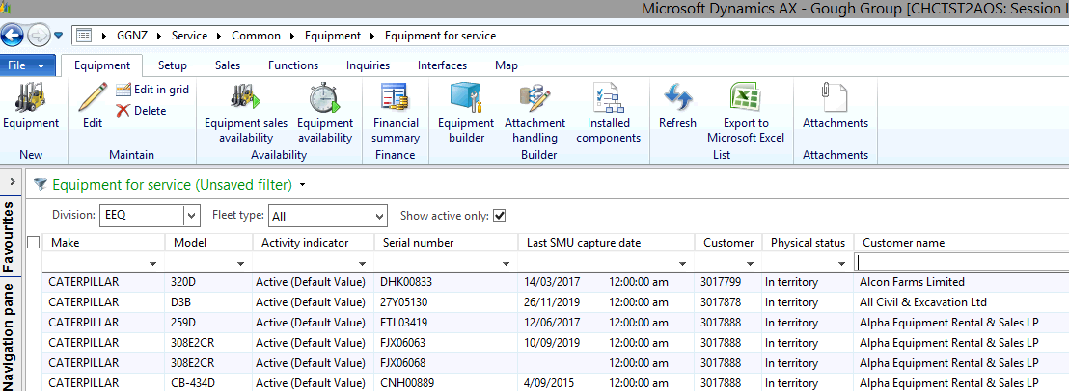

### General

|  |  |  |
| --- | --- | --- |
| **Field** | **Mandatory** | **Data Standard** |
| Equipment Number | Y | System generated - Unique identification |
| Equipment Name | N | Check SISWEB for correct name. For non-Cat default to Product family based on Model selection |
| Description | N |  |
| Fleet Type | Y | Process driven; Customer - CAT Equipment sold by TC, Competitive - Cat Equipment sold by others, Rental - Rental Fleet, Component if it's an engine or genset |
| Agreement Status | N | Process driven; Sold - all owned Equipment in population |
| Physical Status | Y | Used by OLGA. If scrapped select Inactive in territory. If exported select Out of territory |
| Reason Code | N | If Out of territory choose either TEMPEX for temporarily exported or EXPORT for permanently exported,  otherwise select another code from the list. Select SCRAP if machine is scrapped If CANCEL is chosen, also tick Exclude from OLGA tickbox |
| Project ID | N |  |

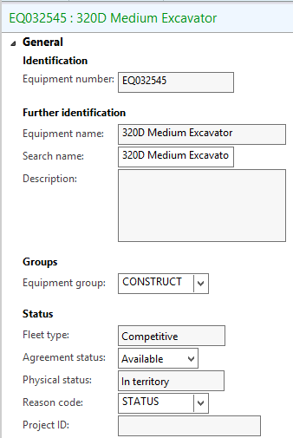

### General > Machine information, Inventory

|  |  |  |
| --- | --- | --- |
| **Field** | **Mandatory** | **Data Standard** |
| Model | Y | If not found, sales admin to add. Ensure correct selection is made to avoid issues later with duplicates or workarounds. |
| Group Code | N | This populates when a model is selected. |
| Make | Y | Populates automatically if Model is selected. |
| Make's own code | Y | Two letter code. Does not have to be unique, but must be populated |
| CAT Make | Y | Only required for Make Caterpillar, otherwise must not be ticked |
| Require SIMS ticket | Y | Only required for Make Caterpillar, otherwise must not be ticked |
| VisionLink / Basic Daily make code | N |  |
| Attachment | N | Tick the box if equipment is an attachment |
| Attached to | N | Select if needed |
| Item Number | Y | Mandatory for purchased equipment. Sales admin to add initial records. |
| Serial Number | Y | Must be capital letters. If not found or equipment is being purchased, update later. (It's only posslbe to leave blank if creating equip from a PO) |
| Configuration | N |  |

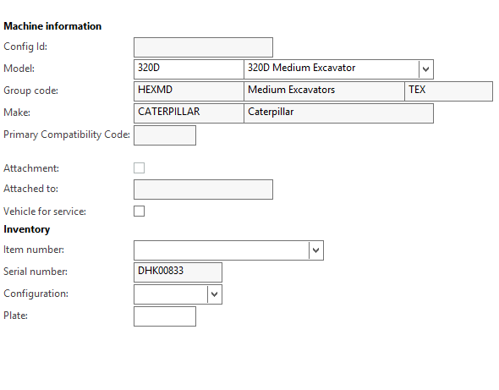

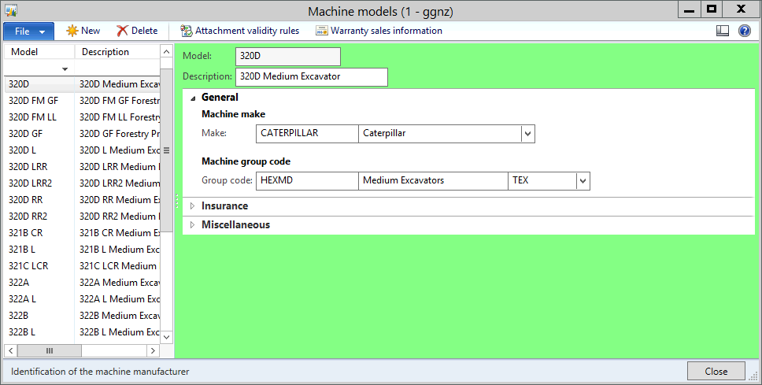

Right click > View details on Make to open Machine makes form

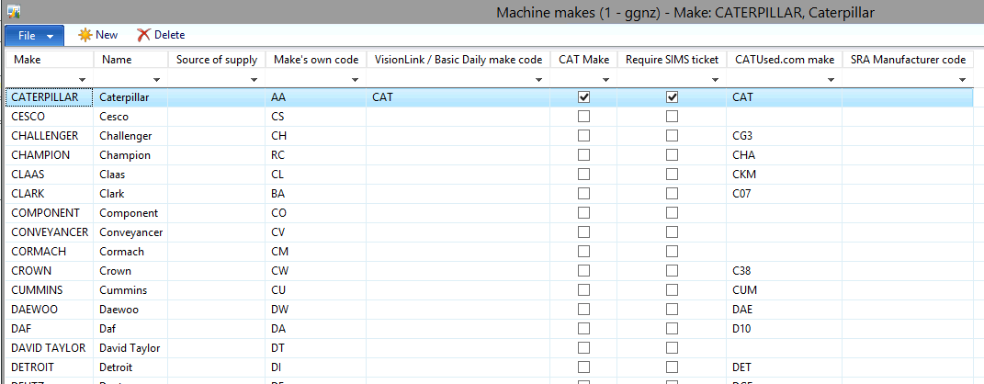

### General > Dates

|  |  |  |
| --- | --- | --- |
| **Field** | **Mandatory** | **Data Standard** |
| Order Date | N | Process driven |
| Manufacture Date | N |  |
| Received Date | N | Process driven |
| Delivery Date | N | Process driven |
| Sell Date | N | Process driven |

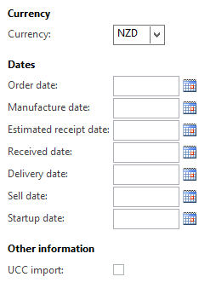

### Technical information

|  |  |  |
| --- | --- | --- |
| **Field** | **Mandatory** | **Data Standard** |
| External Reference | N |  |
| Customer Equipment Number | N |  |
| Inactive | N | Tick the box for equipment that has been traded in, for service vehicles that have been returned, or for aged equipment that has been validated as inactive and investigation is also added to attachment notes. |
| Stolen | N |  |
| Lost | N |  |
| Missing | N |  |
| Damaged | N |  |
| PIN/VIN Code | N |  |
| Manufacture Year | Y | Check SIMSi, if unknown, use 9999 |
| PWC Code | Y | Select from the list |
| Exclude from OLGA | N | Mandatory decision - Tick the box if the equipment belongs to a business unit other than Terra (e.g. Palfinger). Leave unticked for Terra customers' competitors e.g. Komatsu, Hitachi etc |
| Application Code | N | Used by OLGA - for Cat engines only - particularly important for standby engines. |
| Activity Indicator | N |  |

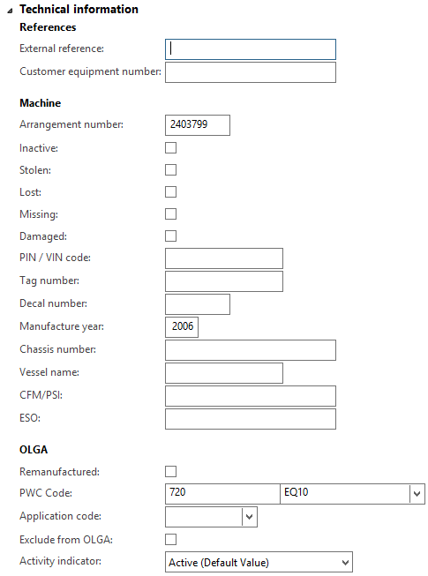

### Technical information > Engine

|  |  |  |
| --- | --- | --- |
| **Field** | **Mandatory** | **Data Standard** |
| Engine Model | N | This is helpful to work out what parts are needed for a repair |
| Engine Arrangement Number | N |  |
| Engine Serial no | N |  |
| Motor Manufacturer | N |  |

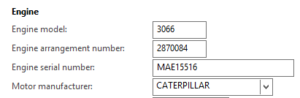

### Usage information

|  |  |  |
| --- | --- | --- |
| **Field** | **Mandatory** | **Data Standard** |
| Estimated Period Usage | N | Enter if known |
| Number of Periods | Y | Enter '1' |
| Period Type | Y | Select 'Day' |
| Last SMU | N | Populate if known |
| Last SMU Capture Date | Y | Populate when last SMU is populated |
| Unit | Y | Select Hours for all equipment, Km for trucks. If not populated, last SMU value will be ignored by SIMSi which may cause issues. |
| Lifetime SMU | N | Pulled from equipment usage history |
| Use CAT feed | N |  |

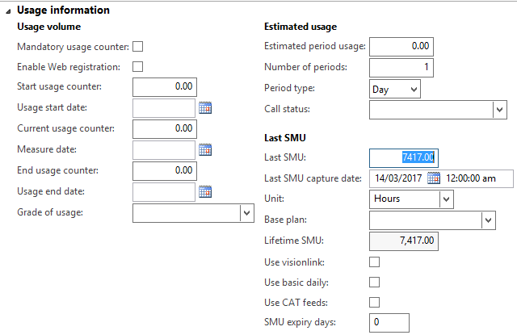

### Trade Information

|  |  |  |
| --- | --- | --- |
| **Field** | **Mandatory** | **Data Standard** |
| Prospect | Y | Must be updated via Functions > Transfer Ownership. Select from the list and do not type to avoid typos |
| Default rental class | N | Select if known |

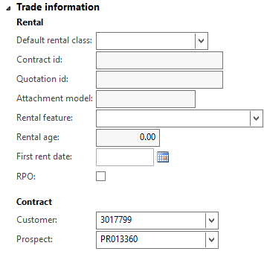

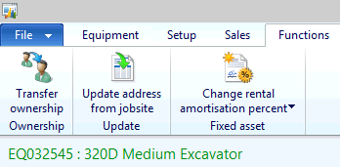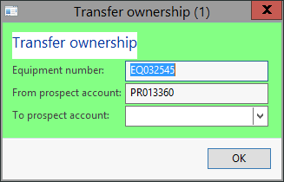

### Financial Dimensions

|  |  |  |
| --- | --- | --- |
| **Field** | **Mandatory** | **Data Standard** |
| Branch | N | N/A |
| Cost Centre | N | N/A |
| Department | Y | e.g. EEQ for Sales, EPS for Power Systems |
| Division | Y | e.g. EEQ for Sales, EPS for Power Systems |
| Equipment | Y | Auto populated from General section |

